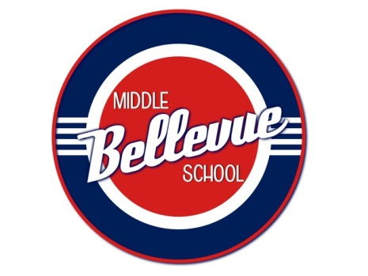

Month, date, 2013
We appreciate your organization’s partnership with the Bellevue Middle School PTO in seeing the vision of Bellevue Middle School become a reality. Through advanced achievement, quality character and community involvement, we desire for Bellevue Middle School to be a great place to learn!

Bellevue Middle School PTO will host .....

The event will be held ....date... at Bellevue Middle School.

Thank you for you contribution!

Bellevue Middle School PTO
655 Colice-Jeanne Road | Nashville, TN 37221 | (615) 662-3000 | Fax: (615) 662-5728
Committed to excellence…from all…for all.

